*First 5 Amador*

*2021 – 2022*

*Program / Evaluation Report*

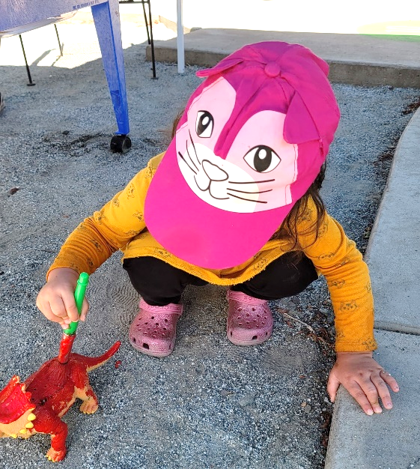

**We are driven by the desire to make systems and programs better serve young children, families, and early care providers. This is accomplished by furthering systems change strategies and by investing where and how it matters most.**

*In 1998, California voters approved a $.50 tax increase on tobacco products through the passage of Proposition 10, the Children and Families First Act. Each county created a local Commission and received revenue to be used for programs for children prenatal through age five.*

**Results - Highlights**

## Imagination Library



Established by Dolly Parton in 1996, the program mails a new, age-appropriate book every month to children enrolled from birth until their fifth birthdays. First 5 Amador began funding the Imagination Library countywide in 2009 to encourage early literacy and strengthen adult and child bonding. Recipients this year totaled 865 children (394 aged 0 – 3 and 471 aged 3 - 5). To date, 2,700 have graduated from the program with more than 100,000 books received by children in their homes. Nearly 60% of age eligible children in Amador County are currently participating.

Children receive a “Welcome Book” – the *Little Engine that Could* upon enrollment and “*Look Out Kindergarten Here I Come*” as they graduate from the program. Surveys conducted in prior years indicate that 20 – 25% more children 0 – 5 benefits from the books due to their caregivers opting out of registering their second or third child. First 5 Amador encourages families to enroll all children as the book titles change each year keeping literacy options in the home new and exciting. Families report children’s excitement when books are received and are one of the commissions most effective marketing strategies. With several services now delivered in-house, staff has seen an increase in enrollment and will continue to a robust marketing campaign to reach all eligible children.

Early childhood and school district personnel continue to share their appreciation of the program and the opportunities it provides children in Amador. Beyond literacy, the consistency of this program supports parent and child bonding by encouraging daily reading. First 5 staff has observed an increase in participation the last quarter of this year and attribute this to more programming occurring on-site such as Welcome Baby, Messy Mornings, playgroups.



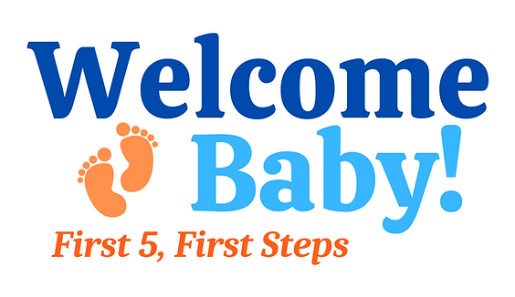

The goal of this universal program is to strengthen family functioning and improve children’s readiness for school by ensuring all new parents have access to the tools needed to optimize their children’s home environment, whatever the socioeconomic status. The Kit for New Parents, developed by First 5 California, is used as the basis for the delivery of parenting information and customized by the family engagement specialist with local resources.

This program was overseen by Amador County Public Health for approximately 20 years. With the long history of the program known to the community as the Baby Welcome Wagon, staff felt it was important to ask families for suggestions regarding a new name. Families participating in First 5 events were surveyed and the new name - “Welcome Baby” was born.

The program provides paraprofessional face to face services offered in the home, in First 5’s Indoor Learning Lab, or a location comfortable for the family (including phone and online visits). The first contact with the family will preferably be actualized in the prenatal period. This visit serves as the arena in which the family can express difficulties or family challenges are detected by the family engagement specialist and services arranged to limit the negative effects on the caregiver and infant relationship. Education regarding Ages and Stages (ASQ/ASQ-SE-2) developmental screenings is incorporated in all visits and the tool is made available for siblings (0 - 5) already in the home.

Welcome Baby is available to all families in the county regardless of income, zip code, number of children in the home, etc. The program builds on each family’s individual strengths ultimately improving the health of their infant as well as overall family strength. Appropriate referrals to services such as WIC, Valley Mountain Regional Center, etc. are provided as well as tangible items such as diapers and wipes for those who are struggling to make ends meet.

Building relationships with hospitals outside Amador has always been challenging for our local home visiting program(s). First 5’s family engagement specialist has done an excellent job building rapport with these hospitals which has resulted in an increase in referrals from social workers. Often, these social workers are connecting with First 5 as many of these families have experienced higher-risk pregnancies and deliveries and now face economic challenges due to travel, time off work, etc.

One hundred six (106) referrals were received during this reporting period with the majority coming from the Sutter Amador Women’s Center. Forty-seven (47) visits were completed with Amador County families. One hundred forty-six (146) siblings in the homes benefitted from the information shared during the visit.

Welcome Baby visits provided an opportunity to enroll families in the Imagination Library making it possible for a newborn to acquire 60 books in their home library by the time they graduate from the program. Introducing families to the importance of early literacy immediately after the birth of their child reinforces the impact talking, reading, and singing has on the development of their child and strengthens the bond with the adults in their life.

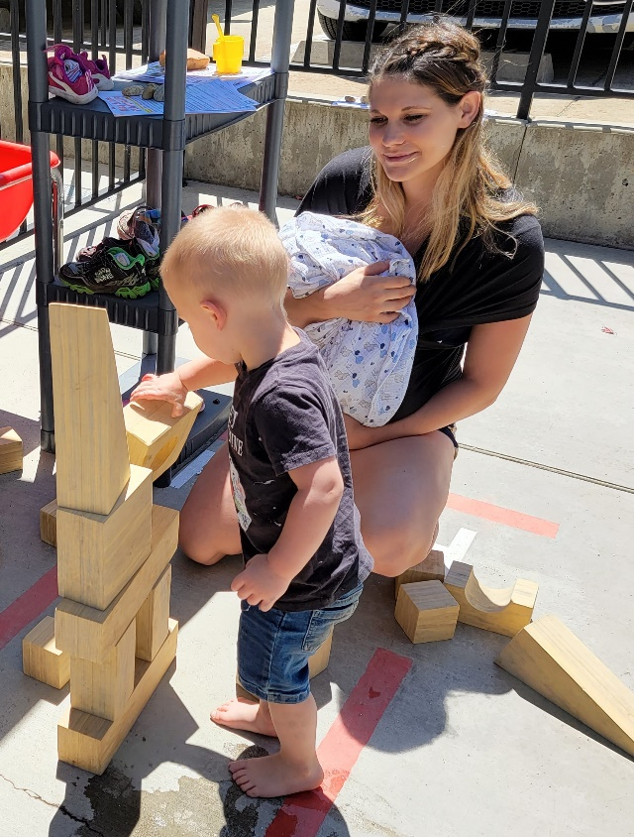

Supporting the adults’ well-being is another important component of Welcome Baby. During the visits, the family engagement specialist offered the Edinburgh Screening to determine if services for perinatal mood and anxiety disorders would be appropriate. During this reporting period 47 screenings were completed with 20% referred to clinical services. These clinical services are provided through a partnership with Amador County Behavioral Health’s Mental Health Services Act. In collaboration with the Amador / Calaveras Perinatal Wellness Coalition, First 5 continued to provide education to the community regarding perinatal mood and anxiety disorders and how and where to seek services.

# Upcountry and Camanche Lake Community Centers

# (Family Resource Centers)

Nexus Youth & Family Services utilized First 5 Amador funding to implement Family Resource

Center (FRC) programs in the unincorporated areas of Upcountry (Pine Grove) and Camanche. Through the FRCs, Nexus provided access to services, socialization opportunities, and early learning programs to ensure that families are strengthened and supported. The goal of the FRCs is to reduce disparities in access to services and programs for families residing in the Upcountry and Camanche areas of Amador County and to increase the success of self-sufficiency, stability, and resiliency. The goal of the school readiness program

**Objective 1:** Children will enter school with the skills for success in life.

**Activity:** Provide a Kindergarten Readiness program once per week at the Upcountry Community Center and Camanche Lake Community Center.

**Program Activity Description:** Nexus implemented a Kindergarten Readiness program for children ages 3 – 5.

Nexus implemented Kindergarten Readiness programs for children ages 3 – 5 once per week at each of the centers. These programs followed the Amador County Unified School District’s calendar to provide a convenient schedule for families. The program was designed to build the school readiness skills which have been outlined by local teachers, administrators, parents and professionals in the following categories: Numbers / Math, Colors and Shapes, Social and Emotional Skills, Reading and Writing Readiness, and Health and Safety.

The coordinator utilized the *Zoo-phonics* system to plan and facilitate center-based activities. *Zoo-phonics* is a program created to help educators implement a developmentally appropriate program for children to learn the alphabet, phonemic awareness, rhyming, pre-sound blending, and pre-writing skills. The system is also utilized by the school district making this strategy a component to a gentle transition to transitional kindergarten or kindergarten.

In addition to facilitating Kindergarten Readiness sessions program staff also utilized the *Zoo-phonics* to create weekly at-home activity packets for enrolled families. Packets aligned with program topics so children and parents could practice and promote early learning fundamentals.

Participation: Throughout the reporting period, 5 children participated in the Kindergarten Readiness program offered at the Upcountry Community Center; the average daily attendance was 2 children. In addition, 3 parents/caregivers with 5 children received take-home activity kits.

A total of 17 children participated in the services at the Camanche Lake Community Center; the average daily attendance was 10 children.

Outreach: In an effort to increase participation at the newer program (Upcountry), staff hosted outreach tables at grocery stores the elementary school, local churches, and community fairs.

Population served: 98% of the children participating in services are eligible for Medi-Cal benefits and/or free and reduced-price school meals.

16 of the children participating in the program were 4 years of age. 17 of the families live in the Ione (95640) area.

Outcome: Throughout the program year children and adults established new friendships. The Kindergarten Readiness Profile (KRP) was utilized as a pre and post assessment to measure the growth and development of school readiness skills children acquired while participating in the program. Staff completed the pre and post assessments with 22 children. All domains of the assessment saw significant increases. Due to the pandemic, educators and parents have expressed concerns regarding children’s social and emotional well-being. These programs offered children born shortly before the pandemic an opportunity to learn not only basic competencies but also engage in social and emotional skill-building which they were unable to explore as toddlers.

Satisfaction Surveys: 13 surveys were completed by families at the end of the program(s). 88% agreed or strongly agreed the program helped enhance their child’s readiness for school and strengthened their parenting skills. 100% felt connected to the staff and other families and were satisfied with the quality of the program.

Objective 2: Parents and caregivers will have information and support to enhance their role as their child’s first, most important teacher; early care and education providers will increase their capacity to serve families with young children.

Activities: Provide monthly Parent and Provider Café interactive workshops on topics that can impact children’s success in school and life.

Program Activity Description: Nexus implemented a series of interactive workshops to share strategies and guidance for parents and providers of children ages 0 – 5 to better support children’s learning and development across five domains: Social and Emotional Development; Cognitive; Language and Literacy; Approaches to Learning. And Physical Development and Health.

Workshops were facilitated by Nexus staff or guest presenter. Although topics were scheduled in advance, staff intentionally maintained a flexible calendar in an effort to adapt and respond to changing trends in family and community needs. Nexus facilitated the monthly events in both in-person and virtual formats. In-person groups met in a variety of locations across the unincorporated areas of the county including the Upcountry and Camanche Lake Community Centers. Staff also held events at the Ione Family Resource Center, Margaret Dalton’s Children’s Center or the Nexus offices in Jackson if a more central location was needed to accommodate interested families and/or guest presenter availability. Nexus also implemented a lending library for participants to check out a device (i.e., tablet) if needed to use at home to log in to the planned events. In October, staff began posting videos of each workshop session on the agency’s YouTube channel.

The grantee reported the following workshops were offered:

Trauma Informed Approach to Understanding Children’s Needs and Feelings, Raising a Resilient Child, Development Healthy Eating Habits for Children, , Building Independence While Setting Limits, Healthy Meals and Snacks on a Budget, Little Kids and Big Feelings, Strategies to Build Social and Emotional Skills at Home, Beating the Winter Blues, The Nature of Nurturing, Understanding and Labeling Children’s Needs and Feelings, Help Your Child Develop Healthy Eating Habits, and Communicating with Respect.

Approximately, 114 individuals attended the cafes either in-person or virtually. At the time of this report, there were approximately 140 views of the Parent and Provider Café online videos.

Objective 3: Families will have the information and support they need to promote and optimize their children’s development to help them succeed in school and life.

Activities: Provide Ages and Stages Development Questionnaires (ASQ-3 and ASQ-SE-2) to parents and caregivers to assist in the monitoring of their child’s development (social-emotional, small / large motor, and cognitive skills). The questionnaire is utilized to celebrate milestones, identify possible delays or concerns and support families with resources to support their child’s development.

Nexus family advocate staff provided outreach, education, screening, and referral services for children ages 0-5. Staff were trained in the implementation of the ASQ-3 and ASQ-SE-2 to learn and discuss the benefits of the tool, how to interpret screening results in relation to referral considerations, the importance of sensitive communication of results, the process for referring children to appropriate agencies, and appropriate activities to encourage at home to support the child’s development.

Service Counts: Throughout this reporting period, family advocate staff disseminated 72 ASQ-3 and 71 ASQ-SE-2 screenings to local families with children ages 0 – 5; a total of 36 screenings were returned for scoring. Staff provided recommendations for 26 families whose assessments indicated the need for support and follow-up as well as case management services for 10 families who assessments indicated the need for monitoring, rescreening, or early intervention. 98% of the children receiving services were eligible for Medi-Cal benefits and/or free and reduced-price school meals.

Screening Outcomes:

62% families received educational materials and support, 27% were provided follow-up (monitoring / rescreening), and 11% were referred to early intervention services.

Program Highlight: During the reporting period, the Family Advocate worked closely with the parents of two young children. The children had been removed from the home due to substantial parental substance abuse which had resulted in both being born with prenatal exposure. The couple was referred to intensive treatment services and the Parenting with a Purpose program as components of their child welfare services case plan. During one parenting class, the mother and father both shared with the instructor that they were struggling to identify, and access needed services to successfully reunify with their children. They stated they felt overwhelmed and anxious because although they were working hard on their sobriety, they needed help arranging visitation time to bond and rebuild trust with their children. The parenting instructor immediately provided a referral to an FRC Family Advocate.

The advocate met with the couple multiple times to assess the situation and identify a course of action to meet their reunification goals. On behalf of the family, the advocate met with their assigned Child Welfare Social worker and was able to request and receive a referral for professional supervised coaching. The advocate and coach then worked together with the family to facilitate increased visitation time, provide ongoing observation and assessment to the social worker, and facilitate additional referrals to support improved family functioning and wellness. During the supervised sessions the advocate observed that the children exhibited possible social-emotional challenges and immediately provided ASQ screenings for the parents to complete. This process was very empowering for the parents who were committed to supporting their children to meet their fullest potential. The results of the screenings indicated the need for follow-up and monitoring and the advocate provided referrals to the Kindergarten Readiness program, Toddler Playgroups, Parent and Provider Café workshops as well as other wellness resources. The parents were eager to participate in every opportunity offered to them and the foster family began the process of enrolling the children in identified services. Before long, the parents completed the treatment program, parenting classes, and supervised visitation requirements and were reunified with their young children.

Today, the family continues to participate in programs and services designed to enhance their parenting skills as well as family health and well-being. They regularly attend Parent and Provider Café workshops and events sponsored by First 5 Amador. They have become FRC peer partners to provide support for other consumers in navigating the social service and behavioral health care systems as well as accessing early care and education opportunities. The children continue to attend summer socialization programs such as Summertime Fun, Messy Mornings, and Dad and Me activities. They have shown significant growth in their goals toward wellness.

# Perinatal Wellness

# Improved mental health and well-being for Amador families

# before and after delivery.

Research tells us that as many as 1 in 7 moms (1 in 10 dads) experience symptoms of depression and anxiety during the postpartum period. People in every age, income level and culture can develop Perinatal Mood and Anxiety Disorders (PMADs) during pregnancy and within the first year after delivery. To address these concerns, First 5 and Amador County's Public Health Department brought together local agencies and organizations to establish the Amador - Calaveras Perinatal Wellness Coalition. Due to the high number of Calaveras babies born at the Sutter Amador Hospital, it made sense to include Calaveras agencies and organizations in the Coalition.

First 5 Amador continued to coordinate Coalition meetings and participate in ongoing activities. The Coalition continued to have a robust level of participation from the hospital, Amador Public and Behavioral Health, community-based organizations, private clinicians, and a retired OB/Gyn. The Coalition’s ongoing work and accomplishments include training for professionals and paraprofessionals; reviewing and refining an algorithm that provides details regarding screening, resource and referral services and clinical treatment. The Coalition continued to distribute educational / outreach material that clinicians credit to positive outcomes for families experiencing PMADs.

The Coalition continued to identify areas for improvement in the comprehensive system. An example of such is a newly developed policy for the emergency room at Sutter Amador Hospital.

Amador's Welcome Baby program continued to provide support during visits with families experiencing perinatal mood and anxiety disorders. The home visitor offers an

Edinburgh screening at all visits and follows-up with referrals to clinical services and support.

Clinical services: 23 women were referred and followed through with services provided by marriage and family therapists and licensed clinical social workers coordinated through First 5 utilizing MHSA funding.

# Playgroups

# (Jackson, Ione, Pine Grove, Camanche Lake)

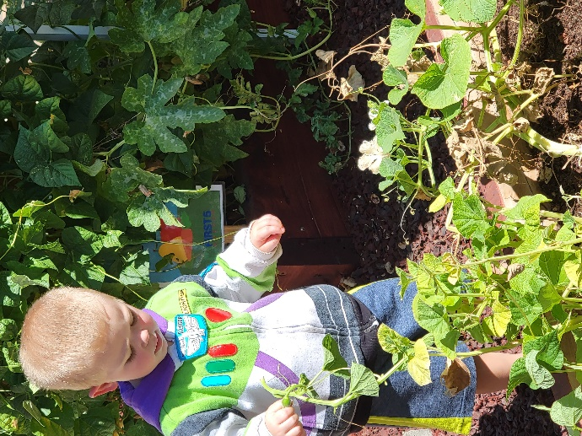

**Playgroups offer safe and supportive environments that provide early learning opportunities and social connections for young children and those who love and care for them.**

Once referred to as “Toddler Playgroups,” these weekly events offered in four locations throughout the county (Jackson, Ione, Pine Grove and Camanche Lake). Playgroups are open to all children in Amador from birth through age 5. These events are designed to be drop-in and provide quality time for the children and adults.

Playgroups also offer support to parents / caregivers by providing information regarding community events, other services in the community and access to early childhood development screenings (Ages and Stages Developmental Screenings – ASQ-3 / ASQ-SE-2). These parent-led screenings help families understand typical development and milestones and what they can do to encourage and support their child. Staff scores the screenings and provides families with suggestions regarding appropriate activities and resources for referrals to early intervention services. The playgroups provide parents and caregivers a comfortable space for social interaction, community networking, and an opportunity to play/interact with their child/ren.

Participation: 120 (unduplicated) children benefitted from playgroups throughout the year. Due to the pandemic, delivery of services was adjusted during this reporting period with take-home kits being an option for families not yet comfortable with meeting in person. The Jackson site continued to see in-person participation rates of children ranging from 5 – 20, Pine Grove 0 - 10, Ione 3 – 17, and Camanche Lake 0 – 1. Staff attributes the pandemic as well as a change in the facilitator to the inconsistency in attendance. Take-home kit distribution at each site continued to be popular with 10 – 20 distributed weekly at each site. Each kit included a book and activities that followed the theme of the book. Information regarding programs such as the Imagination Library and community events were included each week. The facilitator provided the kits to the Family Resource Center staff at the Pine Grove and Camanche Lake sites to distribute throughout the week so that families benefited from the activities and information.

The structure of the in-person playgroup consisted of a welcome and greeting; exploratory play; lesson - activity; story / circle time; a healthy snack / water (often infused with fruit / vegetables); and clean up.

When parents arrived, they often shared with the coordinator comments their children had shared prior to or following playgroup. Children anticipate the weekly playgroup, and it takes only a few weeks for the routine to be set and children to feel comfortable.

Three or four stations of activities such as painting, drawing, puppet play, and dress-up / pretend are provided each week. A large group activity for physical development and play is incorporated into the structure of the playgroup. *Zoo-phonics* is utilized to introduce the children to letters and literacy.

Most adults are grandparents, mothers or small family childcare providers with several fathers attending periodically. Time for parent-to-parent interaction occurs during free play. The conversations are rich with parents sharing information such as local medical care options, favorite outdoor areas that are safe for small children, and support for each other regarding family stressors.

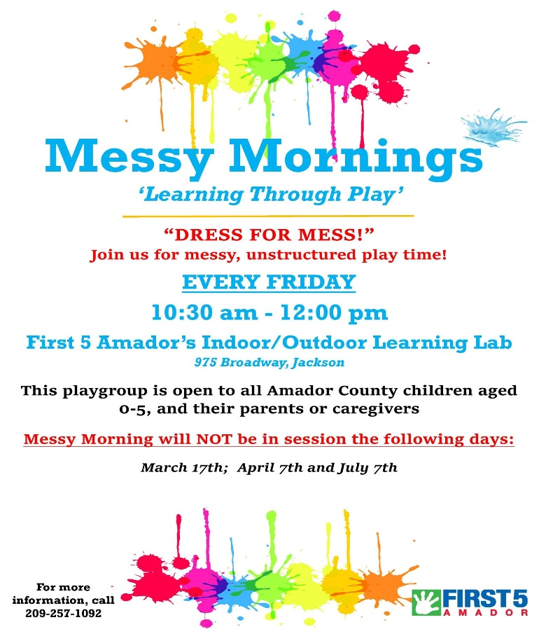

First 5 Amador provides an opportunity for children and their caregivers to participate in weekly events focused on unstructured child-led play. Activities include gardening, painting, building, science, taste-testing, and large motor play (tricycles, wagons, obstacle courses, etc.). This program launched the spring of this fiscal year and has been well-received by families. Weekly attendance continues to be 20 – 35 children plus their caregivers. Shady sitting areas for families with infants are provided and have created opportunities for peer sharing and new friendships. Community partners such as Head Start are invited to share information regarding their programs. T-shirts for the children and parents were distributed to promote the program and provide appropriate attire for “messy play.” Information regarding Ages and Stages Developmental screenings and resources is made available at each event and referrals for children who would benefit from additional services are provided.

.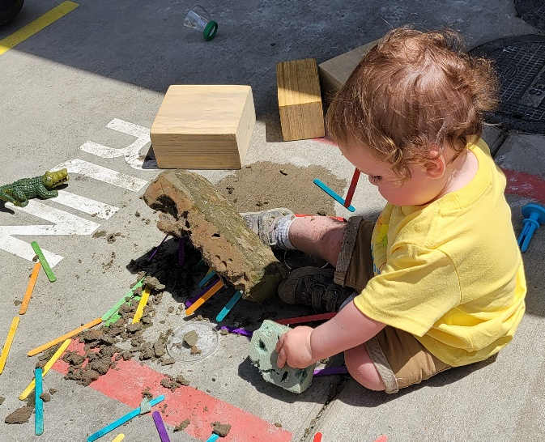 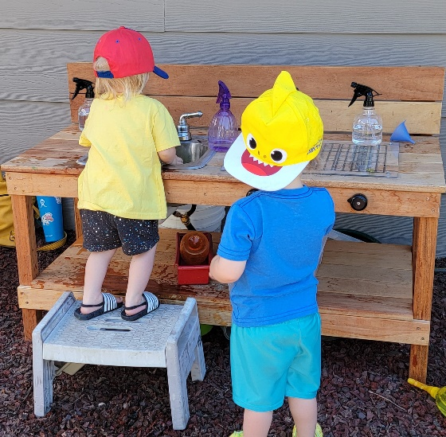

# Transition to Kindergarten

**Kindergarten Bridge Program**

### Background

The Bridge Program in Amador County began in 2003 and initially served 16 children. This program was designed for children who would be entering kindergarten in the fall and had spent little or no time in a preschool setting. The program was designed to introduce the children to the structure and rhythm of the classroom. It was called a Bridge Program because it was aimed to help children cross from the pre-kindergarten environment to kindergarten.

This year’s attendance decreased by approximately 50% from prior years. Staff is attributing this to the pandemic, introduction of transitional kindergarten in the district and the lack of available teaching staff. Fifty-six (56) children attended the program at 5 out of 6 elementary schools in Amador. First 5 staff was unable to recruit teaching staff for Pioneer Elementary. Filling in as a substitute for teaching staff, First 5’s early learning staff was able to observe first-hand some of the challenges children were experiencing due to the lack of interaction and social opportunities during the pandemic. Children’s social and emotional skills were significantly different from that observed in prior years, small motor skills were not as developed, and children who would benefit from early intervention had not been identified and referred to school district services.

First 5 utilized the school district’s food program and delivered meals daily to each of the sites. “Tuesday envelopes” that mimic the school district’s communication strategy with families is implemented each year during the Bridge Program. This not only demonstrates to parents how information will be sent home but provides an opportunity for First 5 and teaching staff to share educational materials, events, and school readiness resources.



**Bridge to Kindergarten Calendar Book**

First 5 continued to distribute Kindergarten Bridge Calendars to families with children 3 years and older to encourage activities at home to prepare them for school. The objective is to support learning through everyday actions such as sorting laundry, reading signs and labels at grocery stores and while travelling so that education and discovery is occurring daily.



Quality Counts California is a collaborative approach that forges partnerships between First 5 California, the California Department of Education and counties to achieve the goal of helping children ages 0 through 5 and their families thrive by increasing the number of high-quality early learning settings, including supporting and engaging families in the early learning process. Multiple funding sources are utilized to meet the needs of the childcare providers, preschool teachers and parents in each county. Amador’s initiative is – Amador Quality for Kids (Q4K) and involves a coalition of individuals representing First 5, the Resource Connection, Amador College Connect, private providers, and the Amador County Unified School District.

Participation rate in Q4K continued to be high with 27 family childcare homes (up from 24), 9 centers (down from 12), and three (3) family, friend and neighbor providers actively engaged. Participants also include “alternate” sites such as playgroups. Families and caregivers are invited to attend all educational opportunities. Participants receive incentives for completing the goals they identified through their Quality Improvement Plans.

Q4K participants completed a total of 40 hours of early childhood education college units. Thirteen participants completed 25 hours of professional development including three family, friend, and neighbor providers.

Twenty participants were engaged in the Q4K Literacy Campaign which encouraged reading and the completion of monthly tracking logs. Families were also encouraged to participate in the campaign and submit their reading logs to be entered in a drawing. A five-foot-tall thermometer was displayed on First 5’s fence to measure the number of books read each month. The objective was to remind families and providers of the importance of early literacy. The campaign was extremely successful with more than 9,000 books read by Q4K participants and local families.

Family, friend, and neighbor (FFN) participants (and potential participants) took part in an early learning activity kit program (Busy Bags) distributed monthly at First 5 Amador. Kits included books, developmentally appropriate activities that built on the theme of the children’s book as well as information regarding early childhood development, events, and local resources.

Amador’s P.E.E.R. (Provider Early Education Resource) supported family childcare participants by providing support utilizing Coaching Companion as well as workshops and meetings to share ideas and address challenging situations with children, families, licensing, etc. Social / emotional “Tips” that were shared on Facebook the first six months of the year focused on a book from the Imagination Library so that families could use what they had at home and/or access the story online. These are extremely popular and frequently receive comments from parents as well as providers.

Incentives for participation in quality improvement activities included implementation of systems changes such as the incorporation of Ages and Stages Developmental Screenings (ASQ) and administration of environmental rating scales (ECERS). Two providers received incentives for achieving a 70% ASQ return rate by families with children in their care.

Amador's Quality for Kids consortia includes members from the Child Care Council, State Preschool, Nexus Youth and Family Services, Amador County Adult Education, ATCAA - Head Start, private preschools, The Resource Connection, Amador College Connect and First 5. First 5 continued to lead the consortia. Q4K collaborated with our local resource and referral agency to distribute COVID-related items to assist early care providers as needed throughout the fiscal year.

#### 

# Dad and Me

# (Grandpas, Uncles, Brothers, etc.)

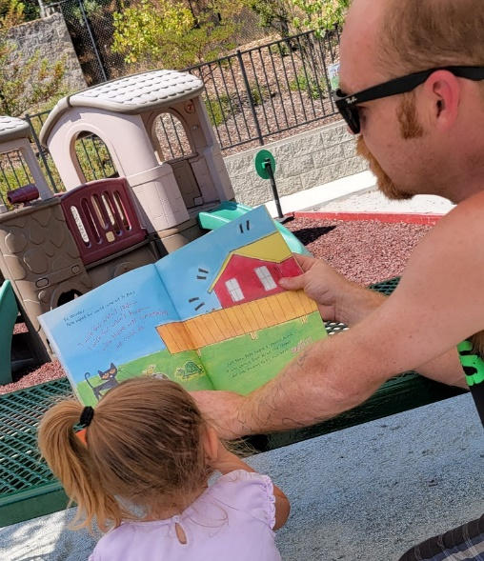

First 5 Amador understands the importance of father-involvement and sponsors Dad & Me monthly events. Research shows that children who grow up with warm, nurturing, and actively involved fathers reap tremendous benefits, including better school performance, increased self-esteem, healthier relationships with peers and caregivers, and future access to greater financial resources, according to a recent review of the research. When fathers read to their young children on a regular basis, they tend to raise children who are superior readers, who perform better in school, and who have better relationship skills (Green, S. 2002)

25 Fathers / grandfathers and 30 children participated throughout the year.

Each of these events:

Provides fun and educational opportunities to help children get ready for school.

Provides opportunities for fathers, grandfathers, uncles, etc. to foster relationships.

Provides families with ideas for future family field trips and activities.

Encourages literacy with each family taking home a book related to the activity.

Due to the pandemic, the delivery of the Dad and Me program followed the playgroup strategy of activity kit distributions and child-led free play with options such as painting, gardening, etc. in First 5’s outdoor learning lab. Early learning activity kits continue to be a successful strategy that has been embedded in multiple programs.

# Mental Health / Social-Emotional Well-Being

First 5 Amador offered consultation services through our partnership with Behavioral Health’s Mental Health Services Act (MHSA) funding. Services were delivered by experienced behavioral specialists who assisted preschool and childcare providers and stay-at-home families experiencing challenging behavior. These consultants are available to assist family childcare providers and early education teachers with a wide range of resources and services. The consultants offer phone and on-site assistance to programs and families as well a linkages to ongoing services that would benefit children ages 0-5.

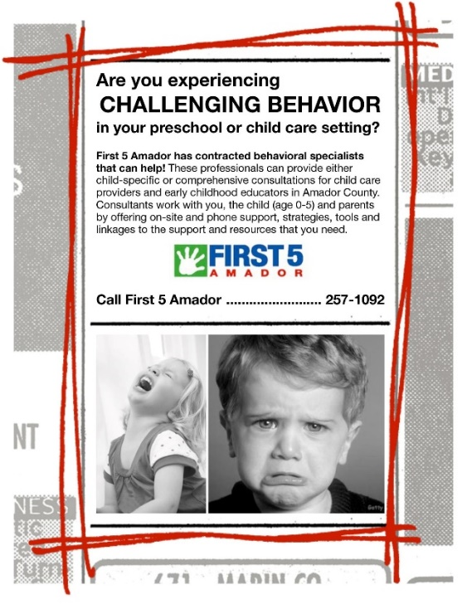

Number of children served: 9 child-specific, 3 comprehensive (preschool sites) – 60 children total

Some of the referrals recommended by the behavioral specialist included Nexus Youth and Family Services for ongoing counseling, perinatal wellness services for a pregnant mom experiencing anxiety and postpartum depression, and Valley Mountain Regional Center for early intervention services.

No child was removed from their current setting due to behavioral concerns. During the last quarter of the year Calming Kits, mental health coloring placemats, crayons, children’s books on stress, and essential goods for struggling families were distributed to address the challenges of the pandemic.

First 5 continued to provide support for families and early care providers by offering training opportunities and resources regarding challenging behavior, stress reduction and self-care.

First 5's monthly e-newsletter and Facebook posts provide information and resources that support children's mental health. First 5 staff continue to be active participants and member of ongoing Behavioral Health / Mental Health Services Act Steering / Cultural Competency meetings and the Student Assistance Program to reinforce the importance of early identification and services for children and families.

Bus ads continue to promote the importance of supporting children’s mental health and developmental screenings.

# Communications and Community Engagement

First 5 Amador’s outreach and education efforts ensure the community has access to the latest information on issues impacting the healthy development of young children. Utilizing the Kit for New Parents, monthly e-newsletters, Facebook, flyer dissemination, radio, newspaper ads/articles, family activity kits and staff sharing at local meetings, First 5 disseminates information regarding services and resources for young children and those who care for them.

First 5’s Messy Morning participants walked in the opening day parade on Kids Day at the Amador County Fair. Art projects and a banner created at Messy Mornings were displayed in the children’s art building at the fair and used as the backdrop for the photo booth. Families learned about involvement in the fair and thoroughly enjoyed having their children’s art available to share with friends and family. A participating family reported it was one of the highlights of their year.

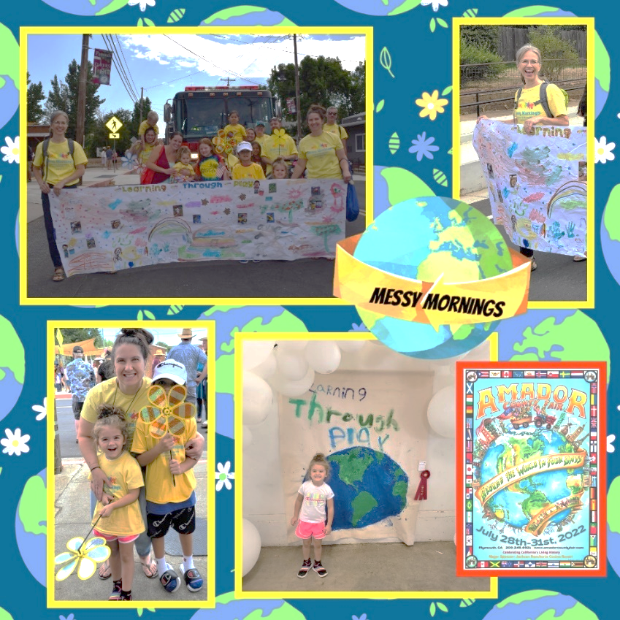

To address the stigma associated with mental health, First 5 Amador continued to create and distribute information regarding early childhood mental health as well as perinatal mood and anxiety disorders. First 5 continued to educate parents, caregivers, early care providers and the community at-large regarding the importance of early identification and treatment through developmental screening for children and perinatal wellness screening for parents. Throughout the year, First 5 purchased and distributed books regarding social and emotional well-being to community partners serving children 0 – 5 including the Pregnancy Help Center, Behavioral Health, and Nexus Youth and Family Services.

# Communications and Community Engagement (Continued)

First 5 is an active member of the Amador / Calaveras Breastfeeding Coalition and applied for a grant on behalf of the Coalition to establish two nursing nooks at the fair. Both sites continue to be utilized and appreciated by families. A local service organization is interested in expanding the pilot location in the children’s art building to create an updated and comfortable space for families. First 5 contributed to the Coalition’s virtual / take-home-kit for the virtual Grandmother Tea during this fiscal year. The objective of the Grandmother Tea is to provide updated information regarding breastfeeding, safety, and early childhood development. The virtual format was utilized this year due to COVID and the Coalition plans to move back to in-person as the pandemic subsides.

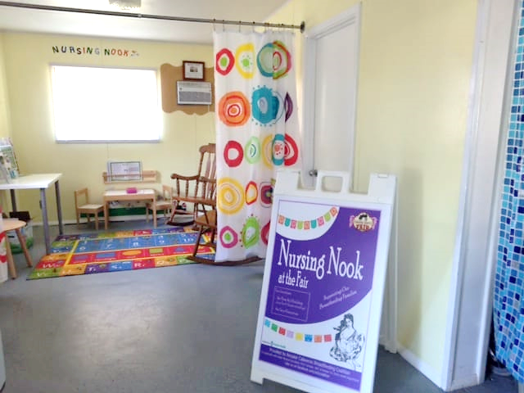

First 5 continued to supply community partners and parents with copies of the **Plays Well with Others – A Guide to Social and Emotional Development**. The guide includes an overview of social and emotional development, local resources, and parenting tips. The guide provides age-by age breakdowns of typical child development, behaviors that warrant concern, and ideas of steps families can take to help foster healthy social and emotional development in their infants and young children.

First 5 staff continued to provide support for Child Welfare Services by providing developmental screening assistance for foster parents caring for children in Amador. The online version of the Ages and Stages Questionnaires allows foster parents an option to meet the requirements for all children under the age of 3. First 5 staff provide results to the child welfare social worker and foster parents so that appropriate resources can be provided to the child/ren.

**First 5’s website, monthly e-newsletter, and Facebook page** provided up-to-date information for parents and providers. First 5 monitors participation rates through data management. Staff has noticed an increase in the number of fathers, policy makers, and community members accessing information provided through our social media efforts.

First 5 hosted a table at the **Winter Wonderland** event held at the Amador County Fairgrounds. This provided an option to the annual First 5 Winter Festivals Around the World event that has not been held recently due to the pandemic.

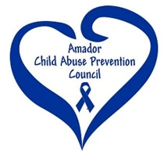First 5provides administrative oversight of the **Amador Child Abuse Prevention Council** (CAPC) / **Resilient Amador**. Activities and outreach topics included Mandated Reporter Trainings, a monthly e-newsletter, mini-grants to support the Council’s mission, newspaper articles / marketing and participation in community events.

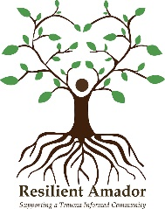Resilient Amador was established to address Adverse Childhood Experiences (ACEs) and Trauma Informed Care. The initiative’s objective is to educate community members about the effects of adverse childhood experiences, trauma-informed care, and how to build resiliency in our community.

**First 5’s facility** (Margaret Dalton Children's Center – rented from the Jackson Rancheria) allows for more community involvement and awareness of the opportunities available for local families. Fitness classes, board meetings, parenting classes, and support groups utilize the facility making it possible to educate more community members about First 5’s mission. The venue provides space for on-site childcare which allows more parents to participate in ongoing activities. Head Start, State Preschool, Kene Me Wu, Nexus Youth and Family Services, Amador-Tuolumne Community Action Agency, and the Amador Child Care Council utilized First 5’s location to host events and educational forums.

First 5 staff continued to take an active role on the Domestic Violence Council, Behavioral Health Advisory Board, Mental Health Services Act Cultural Competency / Steering Committee, Local Child Care Planning Council and Children and Families Program Committee, Tobacco Reduction of Amador County and Amador Dental Partnership (Public Health).

# COVID-19 Pandemic Support Services

The COVID-19 pandemic exacerbated challenges many families and service providers in Amador County were already facing, including economic and mental health issues. In response, First 5, on behalf of multiple community based organizations in Amador, applied for a California Family Resource Center grant which provided funding for resources / supplies including gas, tutoring, school supplies, groceries, diapers, and wipes. Families were referred by the Pregnancy Help and Family Resource Center, Nexus Youth and Family Services, the Amador Tuolumne Community Action Agency, the Resource Connection, Amador County Public Health and Tribal TANF (Temporary Assistance for Needy Families). Approximately 25 families have been served monthly.

“Calming Kits” for early care providers and families were made available. These provide supplies and tips for teaching children self-regulation and stress reduction and encourages providers and families to stop and think before responding to challenging behaviors.

First 5 assisted in the distribution of rapid COVID-19 tests to early care providers and families. Diapers, cleaning supplies, and protective personal equipment (PPE) received from Supply Bank were provided to families and service providers.

Amador County’s Little Free Libraries continue to provide options for families living in every corner of the county. This year, several LFLs were installed bringing the countywide total to 33. The mission of the official Little Free Library program is *to promote literacy and the love of reading by building free book exchanges worldwide and to build a sense of community as we share skills, creativity, and wisdom across generations.* Most Amador LFLs are registered with the international organization and can be located on their website. The Amador County Friends of the Library has established a system for delivering books monthly to each of the LFLs and connects with First 5 to determine the availability of children’s books to include in the distribution.

First 5 staff continue to maintain the map that is shared through social media, curbside events, the local newspaper, etc.

## Oral Health Services and Systems Change

Collaborating with the Amador Dental Partnership through Public Health, First 5 coordinated education and services for families with children 0 – 5 at Celebrate Our Children, the Kindergarten Bridge and School Readiness Programs.

Support during COVID-19 changed due to the lack of in-person services. Dental education was included in Toddler Playgroup, School Readiness and Bridge to Kindergarten take-home kits. Once in-person events were better attended, dental education and screenings were offered at First 5 programs such as playgroups.



Outreach and education during the fiscal year included a bus ad, e-newsletter articles, education through library story times, community events, Toddler Playgroup curbside distributions and Facebook.

## Strengthening Families Framework

First 5 Amador adopted the Strengthening Families Framework – Five Protective Factors – and works closely with community partners and grantees to incorporate the objectives of the framework.

*Research has shown that the Five Protective Factors are linked with lower incidence of child abuse and neglect.*

1. Parental Resilience – the ability to manage and bounce back from all types of challenges that emerge in every family’s life.
2. Social Connections – friends, family members, neighbors, and community members provide emotional support, help solve problems, offer parenting advice, and give concrete assistance to parents.
3. Concrete Support in Times of Need – meeting basic economic needs like food, shelter, clothing, and health care is essential for families to thrive.
4. Knowledge of Parenting and Child Development – accurate information about child development and appropriate expectations for children’s behavioral at every age help parents see their children and youth in a positive light and promote their healthy development.
5. Social and Emotional Competence of Children – a child’s ability to interact positively with others, self-regulate their behavior, and effectively communicate their feelings has a positive impact on their relationships with their family, other adults, and peers.

Challenging behaviors or delayed development can create extra stress for families, so early identification and assistance for both parents and children can head off negative results and keep development on track.

***\*http://www.cssp.org/reform/strengthening-families/the-basics/protective-factors***